Name
Proffesor
Date
Public Piece
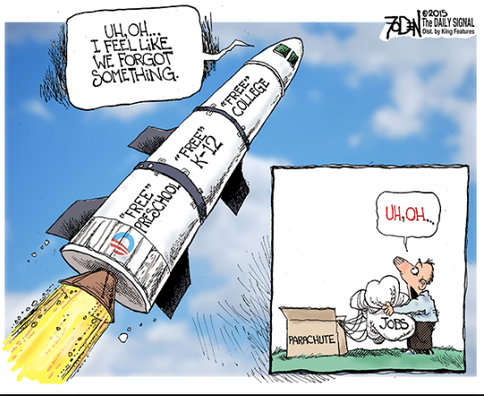

The above cartoon emphasizes on the need for free community college. It has been developed to remind the public and the relevant authorities that there is a need to offer free education college for all students. The country has afforded to provide free preschool, free high school and therefore it should also consider free community college for the education system to be complete. As shown in the cartoon free college is the peak of education, and without it education is incomplete. This piece addresses our problem statement on the need for free community college for all.

Work Cited
https://www.dailysignal.com/2015/01/16/cartoon-free-community-college-going-work/

